

Meet the Teacher

Hi! My name is Mrs. Owens and I am SO excited to be a part of the Grantswood kindergarten team another year. More importantly, I am THRILLED to be your teacher! It’s going to be a fun year full of lots of learning and new adventures and I can’t wait to see what the year has in store for us. I want to know all about you but first, I am going to tell you about me.

Welcome to

Mrs. Owens'

Class

I was born and raised in Birmingham, Alabama and I am the middle child of THREE! I have a younger sister, Valencia, and an older brother, Gerald. I LOVE THEM!! When I graduated from high school, I attended UAB…GO BLAZERS!! I majored in Business at first but changed my major to Early Childhood and Elementary Education. I couldn’t wait to graduate and start teaching! I even went back to UAB and received a MaED in ESL.

I taught kindergarten my first year then looped up to first grade with the same class. I returned to kindergarten my third year and have remained since then. This is my 12th year teaching and I have been here at Grantswood the entire time. I love kindergarten because there are more opportunities to laugh and play, run and jump, sing and dance, and enjoy each other!

I have two daughters name Celeste and Celeen. Celeste is a 19 year old genius who was inducted into the Duke University TIP Program in 5th grade. She is a sophomore at Alabama A&M University in Huntsville and she is fun, fun, fun! Celeen will be 17 years old on August 16th! She is a cheerleader for her high school. She is a shorty pie so we call her “Bean”.

I am so amped up about being your teacher!! I just know this will be the best school year ever!!!!

**A Few of My Favorite Things**

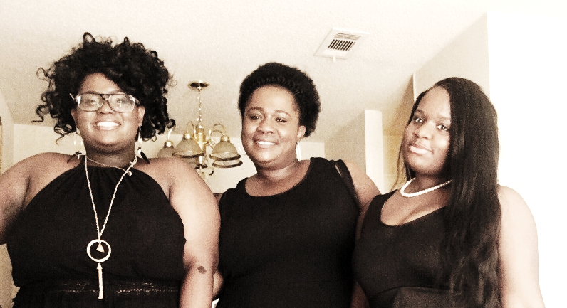Color: Green

Season: Summer

Food: Spaghetti

Fast Food: American Deli

Drink: Lemonade

Sport: Soccer

Animal: Fish

Book: Walk Two Moons

Song: To God Be the Glory

Hobby: Photo Editing

Candy: Twix

Place: Home